The Iowa CARE Project: Make your own QI project
American Board of Pediatrics Website: https://www.abp.org/content/your-own-qi-project
Checklist for application: https://www.abp.org/sites/abp/files/pdf/small_group_qi_project_application_checklist.pdf
Submit on ABP website by Dec. 1, 2023.
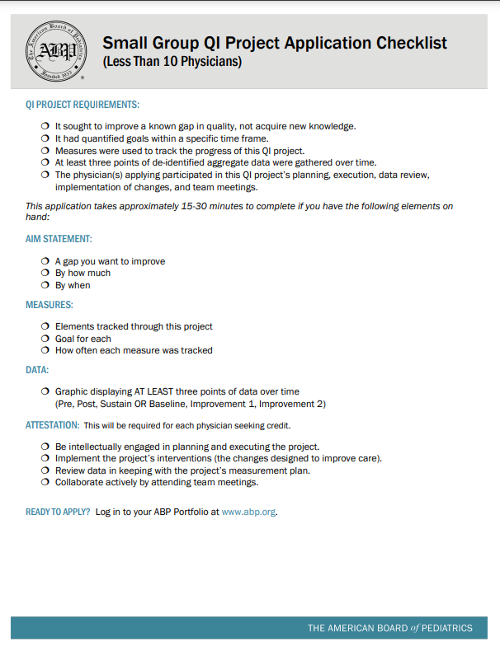
Application questions: https://www.abp.org/sites/public/files/pdf/moc-small-group-qi-application.pdf
Example of clinical project: https://www.abp.org/sites/abp/files/pdf/sqipa-example-clinical.pdf
For the CARE project:
Aim: Improve pediatrician knowledge by 50%, attitudes by 50% and practices by 50% and maintain higher percentage of practices at 1 month follow up regarding early relational health and SSNRs. By August 2023
Elements tracked: Pre- and post- surveys, with 1 follow up sustainable survey
Cycle 1
- Pre-webinar survey
- Deliver Webinar (wait 1 month)
- Post-webinar survey
- Analyze data
Cycle 2
- Introduce digital toolkit (wait 1 month)
- Post-toolkit survey
- Analyze data
Cycle 3:
- Introduce hands-on toolkit (wait 1 month)
- Post-toolkit survey
Finish:
- Collect and analyze all data
- Write it up and submit to ABP

